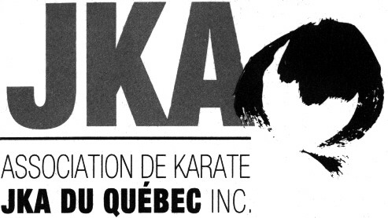 | Winter Camp 2016
 | 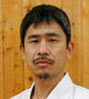 | Koichiro Okuma Sensei,  6th Dan

Participation Form

Last Name : |  |  |  |  | First Name :
Rank : |  |  |  |  | Dojo :

Camp fees
120 $ Full camp (5 trainings) | 75 $ Half camp (3 trainings)
Individual training: 30 $ (cash only) to be paid prior training.
Note to instructors: Send all your students participation forms with one check of the total amount. Please make check payable to AKJKAQ and send to Johanne Hébert, 9-945 Avenue Old Orchard, Montreal, Quebec, H4A 3A3.

Dan and Qualifications exams

Please note that only JKA regular members registered at the Camp, with a valid JKA passports, are eligible to take Dan and Qualifications exams.
Dan Exam fees | Qualification Exams Fees (registration fee included)
250 $ US Shodan | 110 $ US Judge – Level D 110 $ US Judge – Level C
280 $ US Nidan | 110 $ US Instructor – Level D 110 $ US Instructor – Level C
320 $ US Sandan | 160 $ US Examiner – Level D 265 $ US Examiner – Level C
N.B.: People attending Dan exam will meet before training at 15h00 on Saturday February 27th in order to give their Dan registration forms and pay cash (US dollars only) for their exams. You will need your JKA passport, the dates and registration number of your Dan diplomas.

N.B.: People attending Qualification exams will register and pay the registration fee (cash US dollars only) Friday night or Saturday morning before the briefing for Qualifications. Only registered people will be allowed to assist to the Qualification Class.

- In order to take D-level Instructor & Judging qualifications exams you must have attained your 2nd Dan for at least 3 months.
- In order to take D-level Examiner qualification exam you must have attained your 3rd Dan for at least 3 months and have your D-level instructors as well as judging qualifications.

For more information, please contact Manon at (450) 441-1061 or by email karate.jka@videotron.ca.
-----------------------------------------------------------------------
Rules regarding the use of cameras, videos, cellulars, etc. during AKJKAQ activities.

It is strictly forbidden to photograph, film or take pictures with any device without permission from AKJKAQ.

For more information, please contact Jean-Pierre Cusson by email karate.jka@videotron.ca or by phone at
(450) 441-1061.

