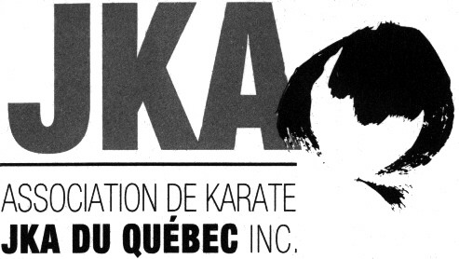 | Winter Camp  26 et 27 February 2022
Sensei Jean-Pierre Cusson, 7th Dan
et
Sensei Louis-A. Dessaint, 7th Dan

Participation Form

Last Name : |  |  |  |  | First Name :
Rank : |  |  |  |  | Dojo :

Winter Camp
Please tick the chosen trainings and the associated fee
26 February, Saturday - Tranings  ___9h00 à 10h15 Green to black belts  ___10h45 à 12h00 Green to black belts | 27 February, Sunday - Trainings  ___8h30 à 10h00 Green to black belts  ___13h00 à 14h00 Brown and black belts

$ 80 4 trainings  $ 60 3 trainings  $ 45 2 trainings  $ 25 1 training  Register in advance, places are limited. | Sanitary measures in force  - A vaccination passport will be required for all individuals aged 13 and over.  - Participants must wear a mask at all times.  - Spectators are prohibited.  - ÉTS lockers are reserved for 18 years plus.
Note to instructors You have until February 24 to send us the registrations and the bank transfer.

DAN AND QUALIFICATION EXAMS
Note to instructors You have until February 20 to send us the registrations for the Dan and qualification exams as well as the bank transfer. Please note that only JKA members in good standing, registered for camp and with a valid JKA passport are eligible for Dan and qualification exams.
Dan Exam Fee | Qualification Exams Fees (registration fee included)
$ 300 CAD Shodan | $ 130 CAD Judge – Level D
$ 340 CAD Nidan | $ 130 CAD Instructor – Level D
$ 380 CAD Sandan | $ 190 CAD Examiner – Level D

N.B.: The karatekas who will take an exam must submit their Dan Exam Record form and/or their JKA passport at the start of the camp.

Eligibility criteria for qualifications exams
Prerequisites for Instructor D: Nidan and 20 years old or more.
Prerequisites for Judge D: Nidan and Instructor D.
Prerequisites for Examiner D: Sandan for at least 3 months, Instructor D, Judge D and 25 years old or more.
** It is possible to take more than one Level D qualifying exam on the same day.

For more information, please contact Jean-Pierre Cusson at (450) 441-1061 or by email karate.jka@videotron.ca.
-----------------------------------------------------------------------
Rules regarding the use of cameras, videos, cellulars, etc. during AKJKAQ activities.
It is strictly forbidden to photograph, film or take pictures with any device without permission from AKJKAQ.
For more information, please contact Jean-Pierre Cusson by email karate.jka@videotron.ca.

